UML Diagrams Overview
UML combines best techniques from data modeling (entity relationship diagrams), business modeling (work flows), object modeling, and component modeling. It can be used with all processes, throughout the software development life cycle, and across different implementation technologies. UML has synthesized the notations of the Booch method, the Object-modeling technique (OMT) and Object-oriented software engineering (OOSE) by fusing them into a single, common and widely usable modeling language. UML aims to be a standard modeling language which can model concurrent and distributed systems.
Use case diagram
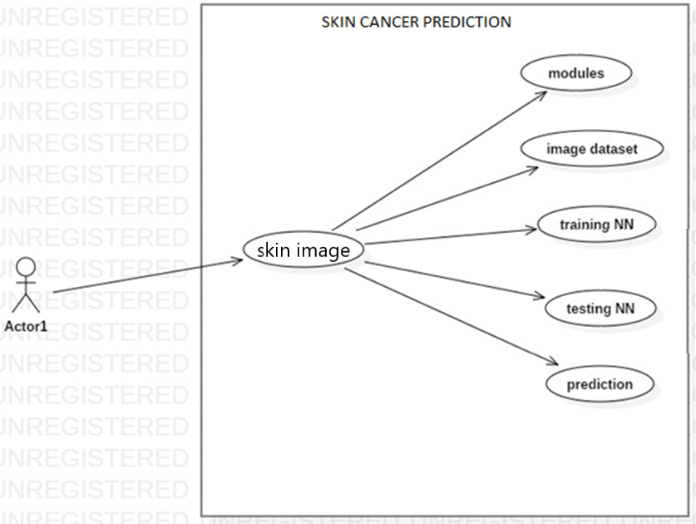
Activity diagram
Activity diagrams are graphical representations of Workflows of stepwise activities and actions with support for choice, iteration and concurrency. In the Unified Modeling Language, activity diagrams can be used to describe the business and operational step-by-step workflows of components in a system. An activity diagram shows the overall flow of control.
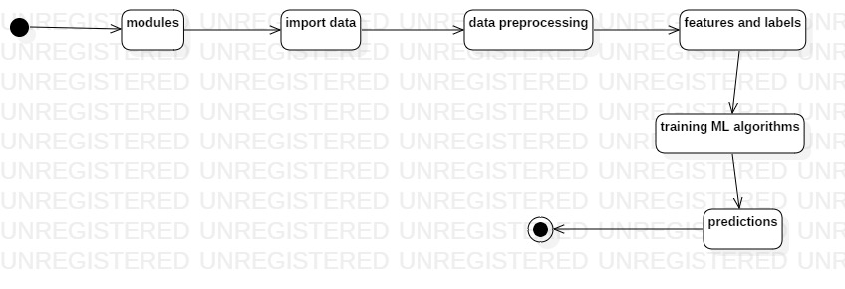
Sequence diagram
A sequence diagram in Unified Modeling Language (UML) is a kind of interaction diagram that shows how processes operate with one another and in what order. It is a construct of a Message Sequence Chart. A sequence diagram shows, as parallel vertical lines ("lifelines"), different processes or objects that live simultaneously, and, as horizontal arrows, the messages exchanged between them, in the order in which they occur. This allows the specification of simple runtime scenarios in a graphical manner.
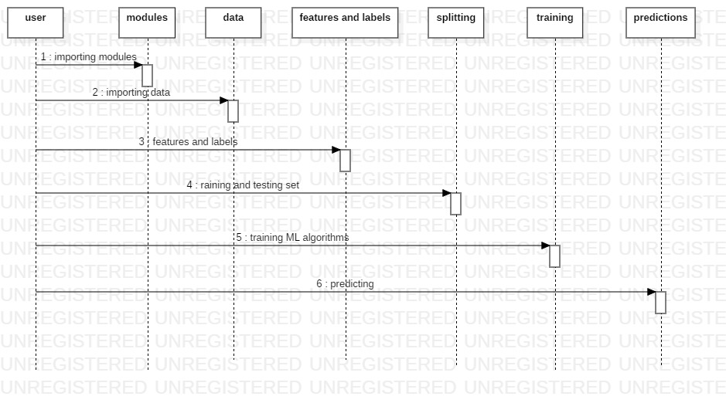
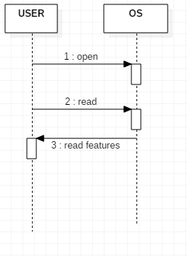
Component diagram
